Primates and Human Evolution. YEAR 12. 2016.

Name___________________________________. Mark= /

|  |  |  |
| --- | --- | --- |
| Test section | Possible mark | Your mark |
| Multiple choice | 10 |  |
| Short answer | 20 |  |
| Total | 30 |  |

***Multiple choice answer sheet.* Use a ball point or ink pen to mark an X** on the letter that represents the best answer from the choice of answers. Marks are not deducted for wrong answers.

|  |  |
| --- | --- |
| Question | Answer |
| 1 | A B C D |
| 2 | A B C D |
| 3 | A B C D |
| 4 | A B C D |
| 5 | A B C D |
| 6 | A B C D |
| 7 | A B C D |
| 8 | A B C D |
| 9 | A B C D |
| 10 | A B C D |

Multiple Choice Section

1. Which of the following would contain the greatest number of species?
2. Kingdom
3. Phylum
4. Species
5. Genus

Look at the three skulls below. Use these drawing to answer questions 2, 3 and 4.

|  |  |  |
| --- | --- | --- |
| A | B | C |
| http://3.bp.blogspot.com/_vZtAOUAS7HQ/SDD6C3TtgHI/AAAAAAAAAIc/b-16E1IpaCk/s400/skull_study_profile-400.png | http://www.transientvisions.com/images/gorilla_skull.jpg | http://4.bp.blogspot.com/_prb792zvLfg/S7qyhS7Gt0I/AAAAAAAAAtg/QUdz7-X3dlU/s1600/Australopithecus.jpg |

1. Which skull shows most Prognation?
2. A
3. B
4. C
5. None of the skulls show Prognation.
6. Which skull has a diastema?
7. A and B
8. B only
9. A only
10. C only
11. Which skull/s are not hominin?
12. A
13. B
14. C
15. A and C
16. Which of the following lists the primates in order of evolution, going from simple to more complex.
17. Lemur, monkeys, apes and Humans.
18. New world monkeys, Old world monkeys and apes.
19. Old world monkeys, new world monkeys and lemurs.
20. Apes, Prosimians, monkeys and Humans.
21. Which of the following will have the largest olfactory center relative to total brain size?
22. New world Monkey
23. Old world Monkey
24. Homo erectus
25. Lemur
26. Which of the following is **not** true of Homo erectus?
27. It had a sloping forehead compared to Homo sapiens.
28. It was able to live in colder climates than Homo habilis.
29. It had a similar cranial capacity to Homo neanderthalensis.
30. It had pentadactyl hands.
31. Which one of the following changes is irrelevant in the evolution of humans?
32. An increase in convolutions of the cerebral cortex.
33. Precision grip.
34. Increased complexity of tool culture.
35. A move from grain to root vegetables in the diet.
36. The change in shape of the lower molars of apes and humans to the Y-5 pattern is presumed to be evolved from :
37. A move away from a generalized diet to predominately fruit diet
38. An upright stance.
39. The need to rip food apart.
40. Eating meat.

Look at this diagram and use it to choose the correct answers for question 11.

[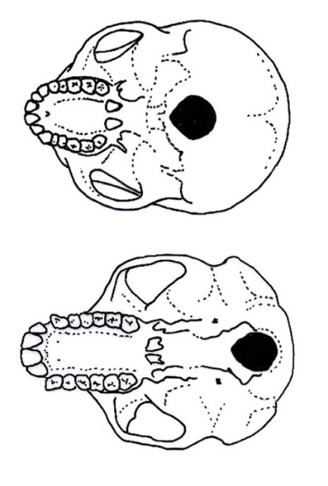](http://www.google.com.au/url?sa=i&rct=j&q=human+foramen+magnum+and+ape+foramen+magnum&source=images&cd=&cad=rja&docid=GZu10pa2Sq9xUM&tbnid=Z1eJ4IXbkGP6DM:&ved=0CAUQjRw&url=http://australianmuseum.net.au/image/Undersides-of-a-human-and-a-chimpanzee-skull&ei=okUyUoKYLMWFkAWA9YH4Bg&psig=AFQjCNHfHu1Y0VC_PCg78305teS8wfw0TA&ust=1379112690280839)

1. 1. The skull on the left is a bipedal primate with reduced prognation and a diastema.
   2. The skull on the left is a bipedal primate with large prognastion and a diastema.
   3. The skull on the right is a bipedal primate with a large prognation and no diastema.
   4. The skull on the right is a bipedal primate with reduced prognation and no diastema.

Short Answer Section

1. Write definitions for all of the words in the table below

(2 marks)

|  |  |
| --- | --- |
| Term | Meaning |
| Arboreal |  |
| Bipedal |  |

1. Describe 4 characteristics of all primates ?

(8 marks)

____________________________________________________________________________________________________________________________________________________________________________________________________________________________________________________________________________________________________________________________________________________________________________________________________________________________________________________________________________________________________________________________________________________________________________________________________________________________________________________________________________________________________________________________________________________________________________________________________________________________________________________________________________________________________________________________________________________________________________________________________________________________________________________________________________________________________________________________________________________________________

1. Lucy was the skeleton of an Australopithecus found in Africa. She was obviously a Hominin, but not a Homo sapien. List the skeletal characteristics that would indicate she was a Hominin and had evolved to bipedal locomotion.

(10 marks)

_______________________________________________________________________________________________________________________________________________________________________________________________________________________________________________________________________________________________________________________________________________________________________________________________________________________________________________________________________________________________________________________________________________________________________________________________

_______________________________________________________________________________________________________________________________________________________________________________________________________________________________________________________________________________________________________________________________________________________________________________________________________________________________________________________________________________________________________________________________________________________________________________________________

______________________________________________________________________________________________________________________________________________________________________________________________________________________________________________________________________________________________________________________________________________________________________________________________________________________________________________________________________________________________________________________________________________________________________________________________

______________________________________________________________________________________________________________________________________________________________________________________________________________________________________________________________________________________________________________________________________________________________________________________________________________________________________________________________________________________________________________________________________________________________________________________________

________________________________________________________________________________________________________________________________________________________________________________________________________________________________________________________________________________________________________________________________________________________________________________________________________________________________________________________________________________________________________________________________________________________________________________________________